SCH4C Introduction to Stoichiometry November 2017

Consider the following recipe for making pancakes:

1 cup of flour  + | 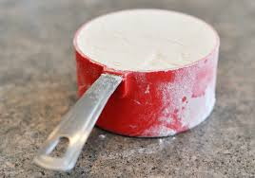 |  | 
1 cup of milk  + | 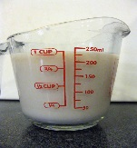
2 tbsp baking powder  + | 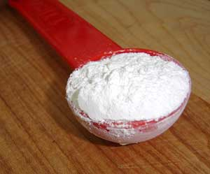
1 egg  + |  |  | 12 pancakes
1 tsp salt | 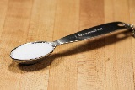 |  | 12 pancakes

We could write this recipe like a chemical reaction:

1Flour + 1Milk + 2Baking soda + 1Egg + 1Salt 12 Pancakes

How would the recipe change if you wanted to make:
- 24 pancakes?

- 6 pancakes

What is important is that the number of each ingredient remains in the _________________________!

1Flour + 1Milk + 2Baking soda + 1Egg + 1Salt 12 Pancakes

How do the amounts of flour and milk compare?

If 3 cups of flour are added, how much milk will need to be added?

If 1 cup of flour is added, how many tbsp. of baking soda need to be added?

If 6 cups of milk are added, how many eggs need to be added?

If 4 eggs are added how many pancakes could be made? (Assuming all the other ingredients are also increased accordingly.)
Ratios are important in chemical reactions as well.

How many of each reactant and product must stay in the same ratio as it is in the _____________________. Remember: In chemistry how many is the unit ________________.

So where did this strange word stoichiometry come from?
It was introduced into chemistry in 1807 and is based on the Greek word for element (stoich) and measurement (metry).

Stoichiometry is the quantitative (how much in moles) relationship between ________________ and __________________ in a chemical reaction.

Consider the reaction below:

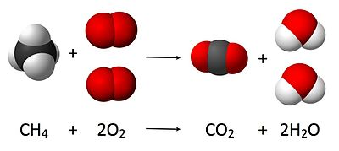

1CH₄ + 2O₂ 1CO₂ + 2H₂O

For every 1 molecule of CH₄ _____ molecules of O₂ are needed OR
For every 1 mole of CH₄ ____ moles of O₂ are needed.

How many moles of water are produced if:
- 3 moles of CH₄ react? ______________
- 2.5 moles of CH₄ react? ______________
- 4 moles of O₂ react? ______________

2H₂ + O₂ 2H₂O

How many moles of water are produced if:
- 1.5 moles of H₂ react? ______________
- 1.2 moles of O₂ react? ______________

3H₂ + N₂ 2NH₃

How many moles of H₂ are needed if:
- 1 moles of N₂ react? ___________
- 4 moles of N₂ react? ___________
- 0.22 moles of N₂ react? ___________

How many moles of N₂ are needed if:
- 3 moles of H₂ are react? ___________
- 9 moles of H₂ react? ___________
- 2.4 moles of H₂ react? ___________

How many moles of NH₃ are formed if:
- 1 moles of N₂ react? ___________
- 2.5 moles of N₂ react? ___________
- 0.134 moles of N₂ react? ___________

What you have just been doing are called mole to mole calculations.

Try the following mole to mole calculations on your own:

2Na + Cl₂ 2NaCl

If 1.5 mol of Na reacts, then ___________ moles of Cl₂ must also react to form ____________ moles of NaCl

4Na + O₂ 2Na₂O

If 0.12 mol of O₂ reacts the __________________ moles of Na must also react to form ____________ moles of Na₂O.

2Al + N₂ 2AlN

In order to produce 0.44 mol of AlN, ______________mol of Al and _________ mol of N₂ must react.

3C + 4H₂ C₃H₈

In order to produce 2.5 mol of C₃H₈, _____________ mol of C and ____________mol of H₂ must react.

